***Astrograph - MLT12F4***

MLT Newton Astrograph are professional telescopes of high “Made in Italy” quality.

Ideal for professional astrophotography, observatories, schools and education.

The telescopes are available in standard sizes 12“, 16“ and ultra portable 16” truss

The carbon sandwich tube and CNC milled components guarantee high quality of all our

telescope optics, an extreme high stability, torsion resistance and collimation.

Instrument loads of greater than 20 kg can be implemented.

***External quotes***

***Technical data***

**Primary Mirror** 25mm th Schott borosilicate glass parabolic 12” F/4 not less

than 15nm Wavefront RMS

**Primary mirror cell** CFRP HS CNC milled; n°9 floating mirror point support

**Tube** Quadriaxial CFRP sandwich structure th 8mm

**Secondary Mirror** 104mm minor axis 18mm th Quartz glass

**Secondary mirror cell** Anodized Alu 6082 alloy

**Secondary mirror spider** CFRP HS CNC milled

**Focuser**  standard installation Pegasus Astro Prodigy 3inch

**Coma Corrector** standard installation 1.14x 3inch for FF format

**Rings**  CFRP HS and Anodized Alu 6082 Alloy CNC milled

**Mount connection** Standard Losmandy frame

**Telescope weight** 18.5Kg including 3”focuser and 3”corrector

***Collimations***

Primary mirror collimation is made by a set of push-pull screws positioned at 120°.

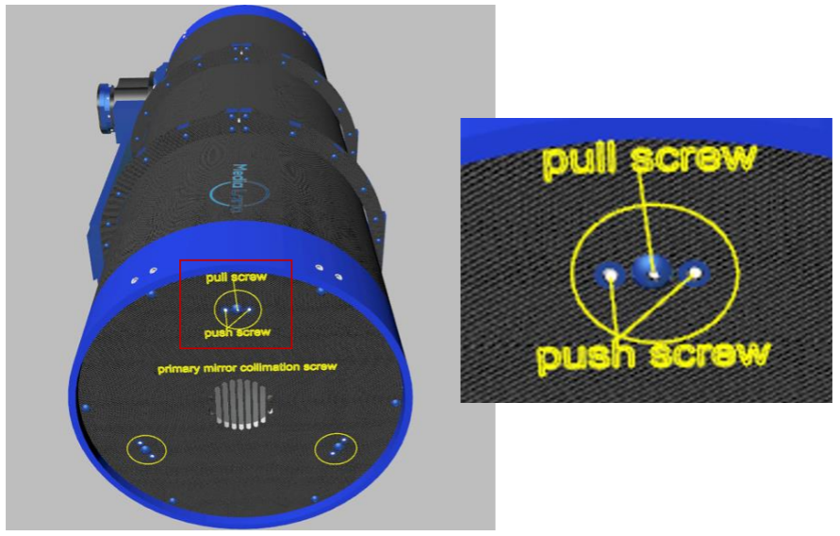

Secondary mirror collimation is done by piston adjuster (already set in factory) and a set of

push 120° screw.

***Cooling fan system***

Cooling system is made by a single fan 80*80x10mm 12V.

The connection is made by GX12 Connector

***Field analysis***

Field Analysis with imx571 sensor (aps-c) - bin1x1

Coma corrector 1.14x - sampling 0.55arcsec/pixel - 60seconds of exposure

***C***

***Coma corrector, backfocus and camera connection***

Using the standard 1.14x 3” coma corrector the backfocus is 72mm.

The Coma corrector 3” has a specific flange (already installed and visible in the picture below) that modify the backfocus from 72mm to 64mm (as in the picture below).

Typical connection for a camera with 55mm of backfocus:

1. Adapted M68 (male) to M54 (male)
2. Adapter M54 (male) to M48 (male)
3. Camera with 55mm backfocus

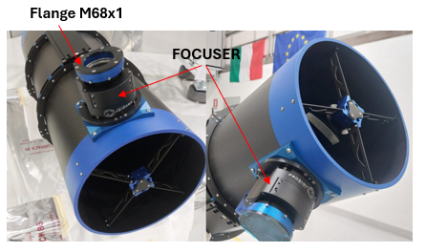

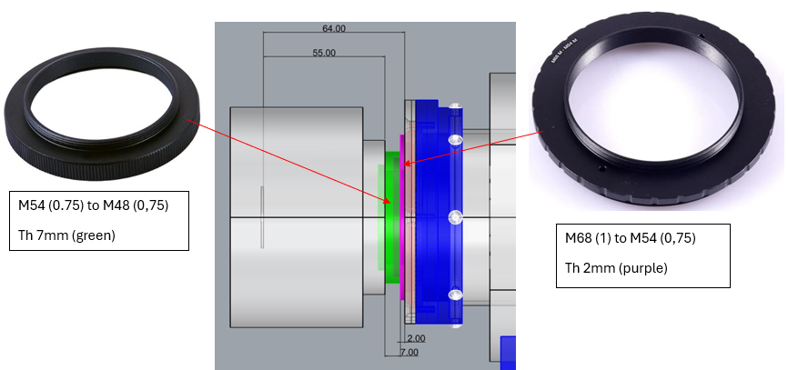

For a correct orientation of the camera it is necessary to lose the n°6 screws (as indicated in the picture below), rotate the camera and tighten again.

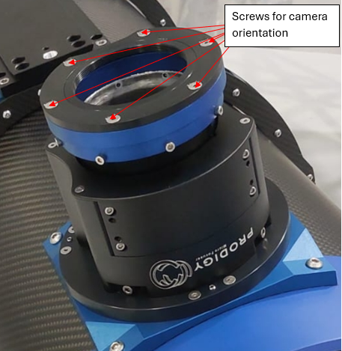

To adjust the distance from the coma corrector to the camera there is a set of M48 spacers 3mm, 5mm, 7mm, 10mm, 12mm, 15mm, 20mm, 30mm.

In the box there is a special spacer (21mm) for the 2” and 1,25” filters.

For Canon connection there is in the box the standard M48 to Canon

***Focuser***

The focuser is a Prodigy Astro 3” (and the coma corrector is already installed). In the box there are all accessories to control the focus manually (by the hand controller) or remote control (by USB cable).

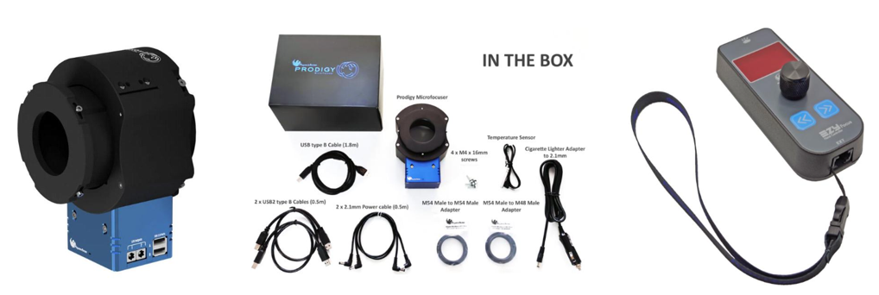

***Safety***

Never use a telescope to look at the Sun without specific filter even a brief glimpse of the

Sun through the telescope can cause irreversible eye damage or permanent blindness, and

if the telescope is inadvertently pointed at the Sun it could cause damage to the instrument.

It is recommended to not use the telescope in daylight hours. If you are using it in the

daytime, keep the lens cap on the finder telescope to avoid accidents with the Sun.

Make sure the telescope is sitting on a secure, level surface removed from edges and tipping

hazards. Avoid setting the telescope up near tripping hazards such as stairs, uneven ground,

or water.

We recommend you allow your eyes at least 10 minutes to adjust to the dark conditions

needed to use the telescope at night; don’t rush to start observing.

We recommend you use a flashlight with a red bulb at night to prevent you from losing your

night vision.

We recommend to avoid any horseplay or shoving and keep foods and liquids away from

the equipment.

Do not leave the equipment unattended, particularly if young children are present.